KDØRC

**FlexRepeaterSpots**

User Manual

Len Koppl, KDØRC

12/31/2024

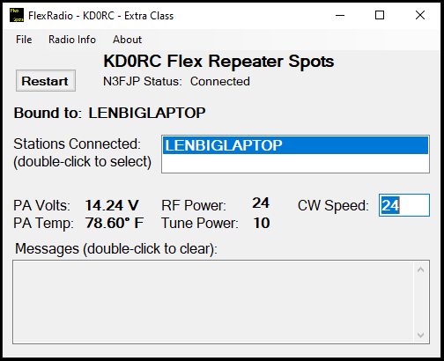

1. Introduction

FlexRepeaterSpots is a utility for Flex 6000 and 8000 series transceivers. It places “permanent” spots on your SmartSDR screen (these spots do not time out like DX spots). The spots indicate the frequency and name of FM repeaters or any frequency that you want one-click access to like nets, calling frequencies or band-edges. A table of FM options is kept for each FM spot such that clicking on a spot applies the appropriate options to the active slice (i.e. the slice that just landed on the spot).

This means that when you see a signal pop up on a repeater frequency that you have a spot for, you can click the spot to navigate to the repeater frequency with all FM options set properly. You no longer need to open the OPT window on the slice flag and set each option manually.

The options that can be set are:

* Mode
* Repeater Offset – FM only
* Offset Direction – FM only
* Transmit Tone Mode (CTCSS_TX or off) – FM only
* Transmit Tone – FM only
* Squelch (on or off)
* Squelch Level
* Spot Color
* Spot Background Color

Each spot is uniquely identified by frequency and name. If there are several spots on the same frequency, but with different options (typically Transmit Tone), giving them unique names allows the proper options to be set for each repeater.

Conversely, several spots with the same name, but different frequencies (e.g. a set of club repeaters) will be seen as unique entities.

Note that changing frequency without clicking the spot will not change the options; it is the act of clicking a spot that causes the options to be changed.

1. Setup
2. Download the FlexRepeaterSpots.zip file and extract all.
3. Run Setup.exe.
4. The utility will execute.

The first time the utility is run, it will create the **C:\KD0RC\FlexRepeaterSpots** directory and place the text file **Config.ini** in it. There is a sample repeater and some instructions in that file to get you started.

The utility will open **Config.ini** in notepad the first time that it is run so that you don’t have to hunt around for the file. The utility will then close of its own accord. Using notepad (or any text editor of your choice), add spots and options in the format shown in the file (see the Configuration File section, below for more information).

One of the files in the zipped file is an example Config.ini. You either copy and paste sections that you want into your Config.ini file or simply replace the whole file with the example file. Edit it to your needs and enjoy!

Make sure that you have spots enabled in SmartSDR:

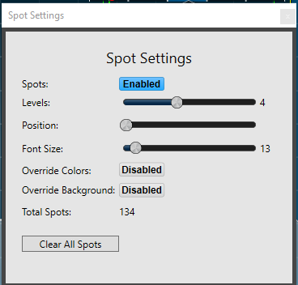

For **SpotColor=** and **SpotBackColor=** to work, **Override Colors** and **Override Background** need to be disabled.

1. N3FJP Setup

If you have ACLog by N3FJP and you want to use the feature that auto fills the Callsign box when clicking on a spot use this procedure with ACLog:

1. Go to Settings
2. Select Application Program Interface (API)…
3. Check the TCP API Enabled (Server) box
4. Confirm that Port is set to 1100

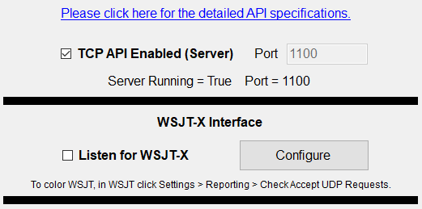

If you have multiple contest versions of N3FJP, each version should have this box checked. Once changed, your choice will be retained even when upgrading.

1. Operation

Once you have your Config.ini file set up, open the app and you should get this screen:



You can minimize it (but leave it running), as there is normally nothing else to do with it. It needs to stay running so that it can set the mode and/or FM options whenever a spot is clicked.

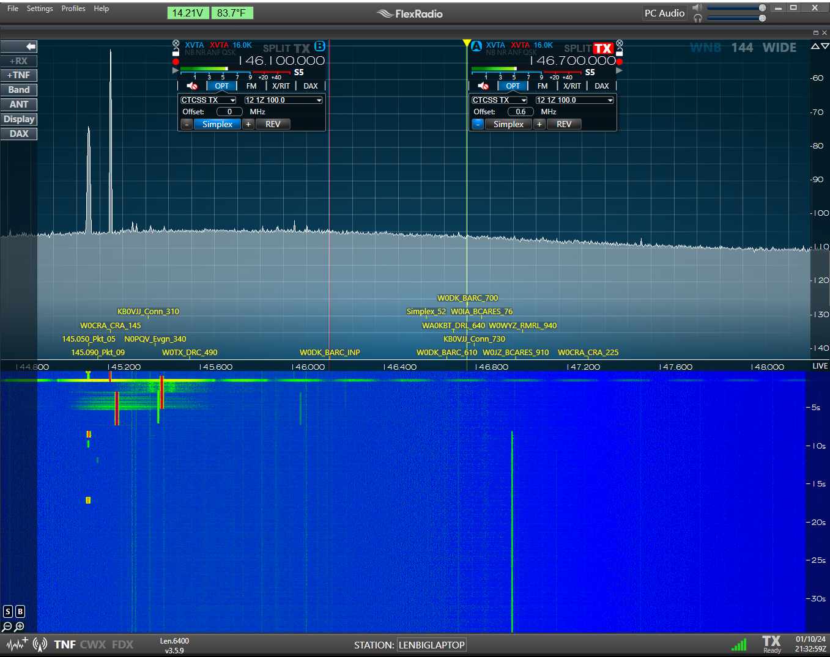

Now you should see all of the spots that you entered. If you open the OPT panel (FM only) on the slice flag(s), you will see the current settings. Click on a spot, and the active slice will go there and the options should now match the options entered in the Config.ini file.

If a slice is already on a spot frequency when you start the FlexRepeaterSpots app, the options may not be what you expect. In that case, make sure the slice is active (i.e. has the yellow triangle and line like Slice A in the example above), then click the spot.

1. Menu
   1. **File**

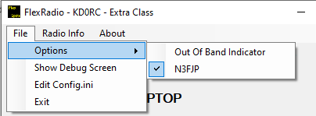

* Options
  + Out Of Band Indicator – Select this option to have the program pop up **\*\*Out_Of_Band\*\*** as a 5 second spot on the SmartSDR screen if you go past a band edge with TX enabled. Band edges are defined by license class. Band edge definitions can be edited in Config.ini.
  + N3FJP – If you use the N3FJP family of loggers, setting this option will cause a clicked DX spot to appear in the Callsign box of N3FJP. This should be unchecked if you don’t use N3FJP. It can also be unchecked if you don’t want to use this feature or just want to turn it off temporarily.
* Show Debug Screen – The program has debug statements to allow debugging connectivity and other issues. Not normally needed, but may be interesting to see if you are interested in the Flex API.
* Edit Config.ini – Opens Config.ini in Windows Notepad (see Configuration File section, below). Don’t forget to click Save after editing the file. A reminder message will appear in the Messages box and the Restart button will turn red to remind you that you need to restart the app for your changes to take effect.
* Exit – Outta here…
  1. **Radio Info**

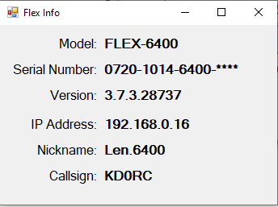

Hover the mouse over the last four digits of the serial number to see them.

1. Controls
   1. **Restart Button**

Restarts the app. Used after editing Config.ini to bring in your changes.

* 1. **Stations Connected:**

Will show the first station found. In the case of MultiFlex, you can change which station the app is “Bound” to. In this application, this is not terribly important, but may be needed for future enhancements.

* 1. **CW Speed:**

CW speed of the bound station. Can be changed by typing a new speed into the box. This is a holdover from another project, but I left it in here just for fun…

* 1. **Messages:**

Any error or informational messages will show up here. Double click in the Message area to clear the box.

* 1. **Other fields:**

All other fields are purely informational. Click on the **PA Temp:** field to toggle between Celsius and Fahrenheit.

1. Configuration File
   1. **Config.ini**

The **Config.ini** file provides a way to customize the functionality and must be in the **C:\KD0RC\FlexRepeaterSpots** directory and named exactly like this to work. This directory will be set up automagically the first time that the app is run.

* 1. **Editing Config.ini**

This file can be edited in any text editor like Windows Notepad. Lines need to end in CR (0xA) or CRLF (0xA 0xD) for the file to function correctly. Notepad takes care of this automatically, so it is a good choice to use.

* 1. **Configuration settings and defaults**
     1. Comments

Comments are preceded with a semicolon “;”. A comment can start at the beginning of a line, in which case the whole line is ignored, even if it contains otherwise legal configuration settings. Comments in the body of a line cause the rest of the line to be ignored.

For example, this line is ignored because of the leading semicolon:

;OOB: ON ; Turns on or off default Out Of Band functionality

If the leading semicolon is removed, the “OOB: ON” configuration will be applied and everything from the second semicolon to the end of the line will be ignored.

* + 1. MyLicense:

Must match one of the six license classes defined (Extra, Advanced, General, Technician, Tech, Novice). Used to determine in band operation for OOB functionality.

* + 1. SpotMem:

ON or OFF. If ON, the Flex memories are read and turned into spots. For FM memories, the repeater options will be applied. If OFF, the memories will work normally, but no spots will be generated for them. Default is OFF.

* + 1. SpotColor:

Default text color to use for spots. This will have no effect on DX spots. Color names can be found at this link: [Colors Class (System.Windows.Media) | Microsoft Learn](https://learn.microsoft.com/en-us/dotnet/api/system.windows.media.colors?view=windowsdesktop-8.0) Default is Yellow.

* + 1. SpotBackColor:

Default background color to use for spots. This will have no effect on DX spots. Color names are the same as for SpotColor. Default is Transparent.

* + 1. SpotMemColor:

Default text color to use for memory spots. This will have no effect on DX spots. Color names can be found at this link: [Colors Class (System.Windows.Media) | Microsoft Learn](https://learn.microsoft.com/en-us/dotnet/api/system.windows.media.colors?view=windowsdesktop-8.0) Default is Yellow.

* + 1. SpotMemBackColor:

Default background color to use for memory spots. This will have no effect on DX spots. Color names are the same as for SpotColor. Default is Transparent.

* + 1. Spot:

Parameters:

* Freq= Frequency in MHz. Ex: freq=14.329. Required.
* Name= 16 characters, no embedded spaces. Ex: Sunday_Flex_Net. Required.
* Mode= Any mode supported by Flex (LSB, USB, AM, CW, DIGL, DIGU, SAM, FM, NFM, DFM, RTTY). Optional.
* Offset= Repeater offset in MHz. Ex: .600. Optional.
* Repeater= Repeater offset direction. Up, Down, Simplex, +, -, S. Optional.
* Tone_mode= Transmitted CTCSS tone on or off. CTCSS_TX, OFF. Optional.
* Tone_val= CTCSS tone to be used when transmitting. Must use Flex tones exactly as seen in the dropdown box under OPT in the flag. Ex: 103.5. Optional.
* Squelch= On or OFF. Optional.
* Squelch_lvl= 0 – 100. Optional
  + 1. OOB:

Values are ON or OFF. Used to send a spot to the SmartSDR screen (requires spots to be enabled in SSDR) indicating out of band for the MyLicense class.

Only used for slice with TX on. Default is OFF.

Supported bands (Frequencies in Hz):

Specified as: Extra low edge, Extra high edge, Advanced low, Advanced High, General low, General high, Tech low, Tech high, Novice low, Novice high. See the example Config.ini file to better understand the format.

* + 1. N3FJP:

Values are ON or OFF. Should only be ON if N3FJP is running. Sets the default state when the app starts. It can be turned on or off dynamically using the N3FJP menu option. When ON, DX spots are sent to the Callsign box of N3FJP when they are clicked. When OFF, they are not sent. Clicking on non-DX spots (i.e. spots set using this utility) will not be copied to the Callsign box.

* + 1. 160 CW:
    2. 160 PHONE:
    3. 80 CW:
    4. 80 PHONE:
    5. 60A CW:
    6. 60A PHONE:
    7. 60B CW:
    8. 60B PHONE:
    9. 60C CW:
    10. 60C PHONE:
    11. 60DCW:
    12. 60D PHONE:
    13. 60E CW:
    14. 60EPHONE:
    15. 40 CW:
    16. 40 PHONE:
    17. 30 CW:
    18. 30 PHONE:
    19. 20 CW:
    20. 20 PHONE:
    21. 17 CW:
    22. 17 PHONE:
    23. 15 CW:
    24. 15 PHONE:
    25. 12 CW:
    26. 12 PHONE:
    27. 10 CW:
    28. 10 PHONE:
    29. 6 CW:
    30. 6 PHONE:
    31. 2 CW:
    32. 2 PHONE:
    33. 1.25 CW:
    34. 1.25 PHONE:
    35. 70cm CW:
    36. 70cm PHONE:
    37. 33cm CW:
    38. 33cm PHONE: